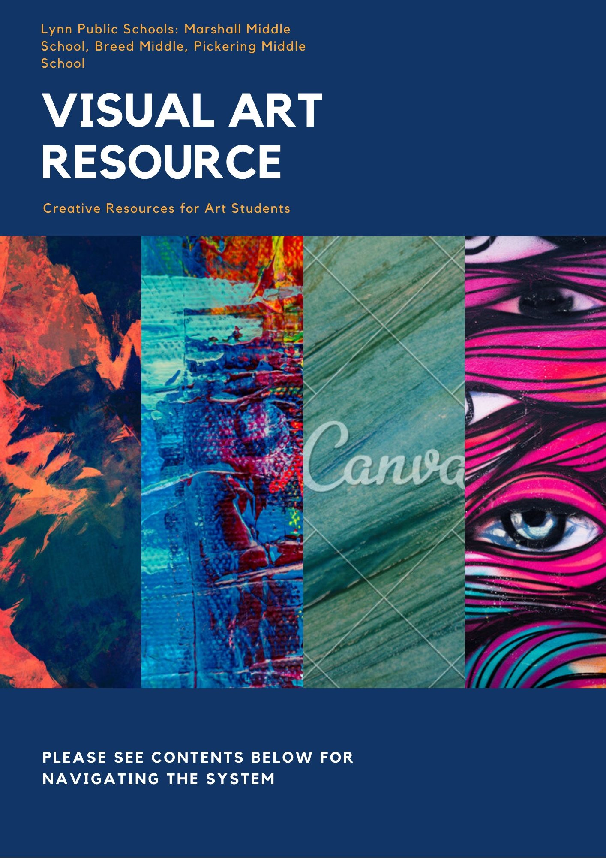

Art Websites
Video and projects
https://mass.pbslearningmedia.org/r3562a50eesource/-1570-4613-945d-883b00d15498/art-basics-with-dick-termes-drawing-cube-basic/

27 Art Activities to try at home
https://theartofeducation.edu/

A Variety of online Art Activites
www.Toytheater.com

Art Educational Website with lessons on Artists, History, Media
https://www.khanacademy.org/humanities/ap-art-history/introduction-ap-arthistory/v/visual-analysis

Videos about inspirational artists and media
https://kqed.org/arts

Create graffiti style name tag
https://www.graffiticreator.net/

Art Apps
Step by Step Drawing Lessons
https://apps.apple.com/au/app/how-to-draw-simple-lessons/id422572351

Painting and drawing app in Neon
https://play.google.com/store/apps/details?id=com.doodlejoy.studio.kidsdoojoy&hl=en_US

Painting/Drawing App
www.Sumopaint.com

Painting Program
https://krita.org/en/

Easy to use Painting Program
http://mypaint.org/

Draw, Paint, Sketch App
https://sketchbook.com/

Color by number
https://play.google.com/store/apps/details?id=com.color.by.number.paint.ly.pixel.art&hl=en_US

Manga and Anime Art
https://medibangpaint.com/en/

Draw and Paint App
https://ibispaint.com/?lang=en-US

Ideas
Nature Art- Research in your backyard and community and create a self portrait
Upcycling-find recycled items in your home and create a sculpture
Online- watch a creative video and create your own art inspired by it

